1. 
2. When writing search query, there are two methods in which you can do this.
   1. 1st: Writing the search query within the request body.   
      This is done by something called the query **DSL**.  
      This is the most flexible and common way of writing search queries and it is also the approach we will use.  
      We add JSON document on the line following the **request URI**.  
      For search query, we then add **query object** which then contains the **query definition**.  
      In this example, query match is **query type** which contains a key which is field name that we want to search.  
      This key is an object itself specifying the value to search for and it can contain **query options** for that field to configure it.  
      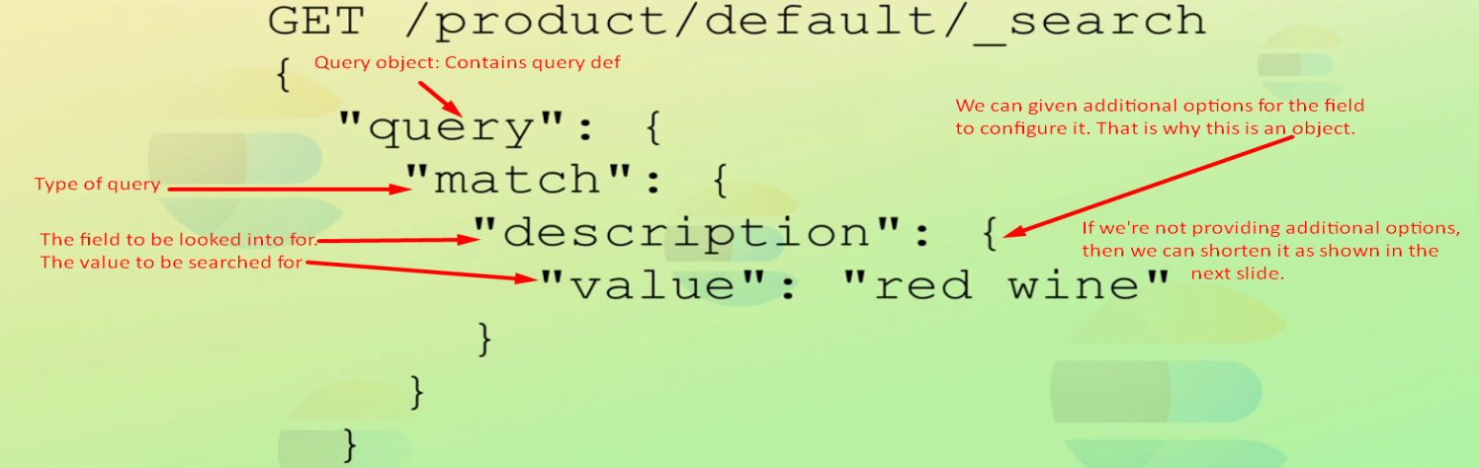  
      In the above example, as we’re not configuring the queries so we can actually shorten the query by specifying the search.  
      NOTE: The above didn’t work on Elasticsearch 7.7.0  
      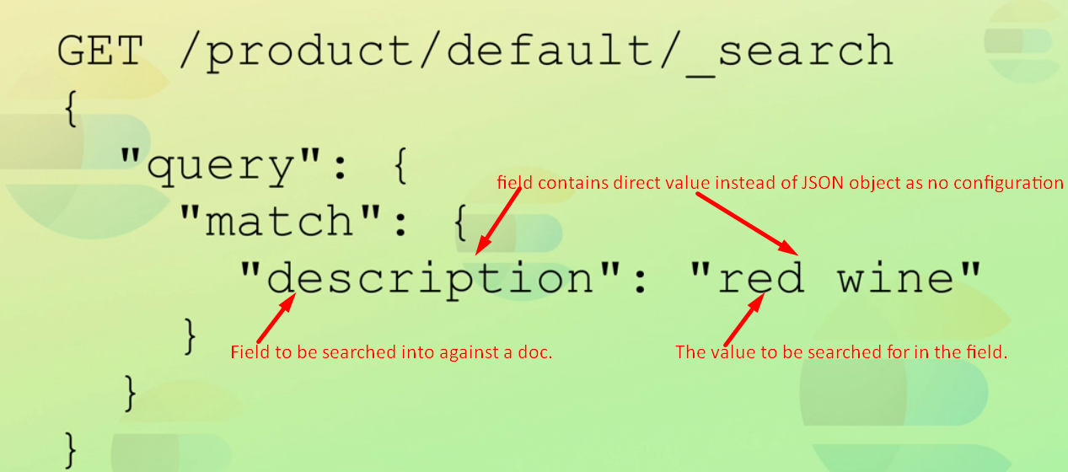  
      So far we saw how to write **DSL query**.  
      The above is working fine on Elasticsearch 7.7.0
   2. Apart from DSL query, it’s possible to perform searches with the URI. That is to embed the **search query** directly in the request you are in.  
      This is referred to as **String query**.  
      You can still perform quite advanced queries with this approach but it’s less expressive and can quickly become difficult to read.  
        
      There are also things that you can’t do with the request URI approach.  
      However this way of searching is very useful for running quick searches perhaps for debugging from the command line or while developing.
3. Interestingly the query DSL actually supports the current **string query syntax** as well.  
   